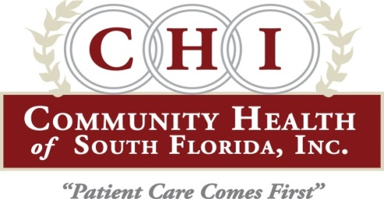

FOR IMMEDIATE RELEASE

Media Contact: Tiffani Helberg July 27, 2017
Office: (305)252-4854
chisouthfl.org

CHI SPONSORS FREE EVENTS FOR NATIONAL HEALTH CENTER WEEK AUG. 12-19
(Miami, FL) – Community Health of South Florida Inc. (CHI) is celebrating National Health Center Week with several free events Aug. 12-19, 2017. The events highlight the resources provided by community health centers like CHI and help to get children physically and emotionally ready for the start of school.
This year the theme is “Celebrating America’s Health Centers: The Key to Healthier Communities.”
In addition to the numerous health fairs that offer free medical, dental and behavioral health screenings, this year CHI will also host two new events to honor law enforcement officials and religious leaders.
“We want to highlight these critical partnerships and express our gratitude,” said Brodes H. Hartley Jr., President/CEO of CHI. “Law enforcement officers help keep our communities safe and they also help bridge the healthcare gap by bringing the mentally ill to care at our facilities and much more. We also know that religious leaders help with the spiritual aspects of health and lead the way to positive health outcomes for our population.”
One in every 15 Americans depend on Community Health Centers for high quality cost effective accessible health care. CHI provides care to more than 75,000 people in South Florida, regardless of their ability to pay or insurance status.
CHI’s National Health Center Week free events include:
- Back to School Health Fair —August 12th from 10 a.m.-2 p.m. at CHI’s Doris Ison Health Center, 10300 SW 216th St., Miami FL 33190. Free health screenings, entertainment, live music, lunch, backpacks, school supplies and educational resources for the entire family. For more information, call (305)252-4853.
- School Physical Day in Monroe County—August 12th CHI will offer free immunizations and school physicals for just $30 at its Marathon Health Center 2855 Overseas Highway, Marathon, FL 33050 from 10am-2 pm and at its Tavernier Health Center 91200 Overseas Highway #17 Tavernier, FL 33070 from 8:30am to 12:30pm. Bring your child’s immunization records.

- Religious Leaders Dinner-- August 14th CHI will honor its religious leaders with a special invitation only dinner.

- Migrant Health Fair-- August 16, at Everglades Housing Community Center, 19308 SW 380th St., Homestead, FL 33034. Free health care screenings, dental screenings, educational resources, food and fun for the whole family, geared to our seasonal farm workers and migrants. For more information, call (305)252-4853.

- Law Enforcement Officers Luncheon—August 17th, CHI will honor law enforcement officers with a special invitation only luncheon.

- Chapman Partnership for the Homeless Health Fair—August 18th CHI will host a fair at Chapman complete with lunch, free health and dental screenings, back packs, school supplies entertainment and more. (The event is closed to the public.)

- School Physical Day for Miami-Dade County— From 8:30 a.m.-12:00 p.m. Saturday, Aug. 19, at all 9 Miami Dade County CHI health centers. School physicals for just $30 and free immunizations. Bring your child’s immunization records. For more information, call (305)252-4853 or go to www.chisouthfl.org for a list of locations.

Community Health of South Florida Inc. is a non-profit health center with 11 health centers and 34 school based health center. It provides primary care, pediatrics, dental, behavioral health, OB/GYN, radiology, vision, pharmacy, laboratory services, urgent care and much more. CHI is a recipient of the Governor’s Sterling Award, it is accredited by the Joint Commission and is also accredited as a Level 3 patient centered medical home by the National Committee for Quality Assurance (the highest level attainable). CHI is also only the second federally qualified health center in the nation to be designated as a behavioral health medical home. In addition, CHI is home to the Brodes H. Hartley Jr. Teaching Health Center, training the next generation of doctors in primary care, psychiatry and OB/GYN.

# # #
For media coverage, contact Tiffani Helberg Vice President of Communications and Development at:
(305)252-4854

